Relationship between full-time education, higher professional occupations and crime
Hamed K. Pour 04/06/2021

Executive Summary

The Census dataset, among other information, provides data on education and occupation at the Middle Super Output Area (MSOA) level, while the Deprivation Index dataset provides information on crime ranking at the Lower Super Output Area (LSOA).
This report utilises the Census dataset and Deprivation Index to explore potential relationships between students, professional occupations and crime. The Census data provides the number of full-time students between the ages of 16-24 and individuals in higher professional occupations between the ages of 25-49. The Deprivation Index is used to provide the crime ranking for each LSOA. A degree of processing and aggregation is required for the LSOA data to be used comparably to that of MSOA data.
This report initially examines whether a relationship exists between the proportion of full-time students and the proportion of individuals in higher professional occupations. It next identifies K-nearest neighbour classifiers for each to help determine whether there is a ‘low’ or ‘high’ conversion of full-time students to higher professional occupations. Finally, the Census and Deprivation Index datasets are used in combination to investigation whether crime ranking may be a factor in limiting the mobility of full-time students into higher professions.
This study finds there to be an overall positive correlation between the proportion of full-time students and individuals in higher professional occupations at the MSOA level.
It further finds that there is no relationship between the proportion of full-time students and crime rank, however there is an apparent positive relationship between the proportion of higher professional occupations and crime rank (with a higher crime rank value equating to less crime within that area). This initially suggests that being in a higher crime area could be a factor influencing the number of people moving into higher occupations from full-time education.
This study recommends that further research be carried out to investigate the relationship between proportions of individuals in full-time education, higher profession occupations and crime ranking at the MSOA and LSOA levels, to build upon the potential relationships outlined in this report.

Aims and Objectives

This study considers two main questions. Firstly, it aims to investigate whether there is any connection between the proportion of full-time students between the ages of 16 and 24 and the proportion of higher professional occupations between the ages of 25 and 49 in the different MSOAs in England. Secondly, it aims to investigate whether the crime rank of an MSOA plays a factor in limiting the number of full-time students moving into higher professional occupations. The study combines two datasets to achieve this. The Census dataset covers the number of full-time students and the number of individuals in higher professional occupations. The second dataset utilised is the Indices of Deprivation which contains crime ranks for LSOAs.

Background to the investigation

Census data helps provide an overview of the state of individuals in society, helping local authorities and organisations to better understand their local and national demographics. This in turn helps inform private and public services such as education, policing and employment (Office for National Statistics, 2021).
Similar to the Census dataset, the Indices of Deprivation dataset helps measure relative deprivation in small areas within England (Department for Communities and Local Government, 2015). Such information is vital for different organisations as it allows them to allocate resources where most needed.
This investigation uses Census data provided for two groups at the MSOA level: full-time students between 16 and 24, and higher profession occupations between 25 and 49. The student age range 16-24 is chosen as this represents the main education years, and the 25-49 range, the main working years for the majority of individuals.
In combination with the Census dataset, the Indices of Deprivation dataset was also used. The Deprivation Index only contains deprivation data at the LSOA level. The combination of these two datasets allows the examination of education and occupation data alongside crime data for different areas of England.
One limitation of both datasets is that they are not directly comparable as their data represents different geographical sizes. The Deprivation dataset covers LSOAs, which are smaller than the MSOAs used in the Census dataset. To overcome this issue, I grouped and aggregated all the LSOAs in the Deprivation dataset into MSOAs. Median was used instead of mean to aggregate, since median is less influenced by potential outliers in the dataset. It is worth noting that aggregation of the dataset results in a reduction of overall accuracy for the study. This was accepted to be a reasonable trade-off to be able to compare the datasets. Finally, in order to merge the two datasets a third dataset was used to connect each LSOA to its respective MSOA.

Scope and sources of data

Census Dataset

The first dataset used in this report is the UK census report DC6206EW (nomis, n.d.a). This dataset covers census data for resident populations aged 16 and over in England and Wales. It is important to note that to protect the privacy of residents and abide by data protection regulations a range of statistical disclosure controls have been applied to this dataset to anonymise the results. This is important to guarantee the protection of the individuals associated with the census (Office for National Statistics, 2011).

Deprivation Dataset

The second dataset used is The English Indices of Deprivation 2015 (Gov.uk, n.d.a). The public Gov.uk website states that this publishes statistical data on relative deprivation for small regions in England. Similarly to the Census dataset, this Deprivation dataset has also been subjected to rigorous data control measures to ensure the protection of individual privacies.

Both datasets are licensed under the Open Government Licence v3.0 which allows the adaptation and manipulation of their information.

The analysis pipeline

Indices of Deprivation data import and preparation

Before the Deprivation dataset was imported into memory, the filename was simplified to make future referencing easier. For the same reason, all empty spaces were removed from the column heading. Beyond this the data did not require any further cleaning.

Census data import and preparation

The census dataset consisted of several files. Before any of these files were imported into memory each file was renamed to reflect the age category it represented. For example, file “85043238.csv” was renamed to “NS_SeC_16_to_24.csv”. Each file also contained metadata which was not needed for the study and was therefore removed. Finally, empty spaces and dashes were removed from column headings and ambiguous column names were renamed. Beyond this no further cleaning was required.

Census data pipeline

Of the four datasets two were selected for the study: NS_SeC_16_to_24 and NS_SeC_24_49. This study focused on two columns in each dataset. Number of full-time students and number of higher professional occupations. My initial attempts at comparing the number of full-time students in each MSOA to the number of higher professional occupations did not bear useful results. This was due to the fact that numbers alone were not a very accurate representation, as some areas were much bigger than others and had therefore larger numbers. In order to overcome this issue, I decided to used proportions instead of numbers and created a new dataset.

The Proportions dataset consisted of three columns; (i) the proportion of full-time students aged 16 to 24, (ii) the proportion of higher professional occupations aged 25 to 49 and (iii) the MSOA name for each entry. This dataset was saved as a csv file for future reuse. It is worth pointing out that I opted not to use a complex database solution such as Postgres or MongoDB for this study since the dataset I was saving was relatively small. More robust database management software, however, would be a great option for further and more complex exploration of this dataset.

To help explore whether there was a connection between these two proportions, I created a scatter plot of the Proportion dataset (see figure 1.0).

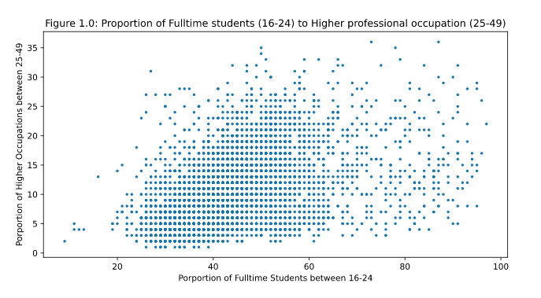
Figure 1.0: Proportion of full-time students (16-24) to higher professional occupations (25-49) by MSOA

As seen in the scatter plot some form of relationship appears to exist, but it was difficult to display this clearly without utilising a regression line. To this effect I included a regression line within the Proportion dataset, which demonstrated a positive trend between these two proportions (see figure 1.2).
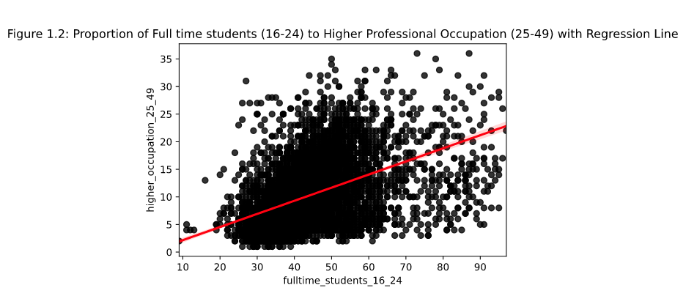
Figure 1.2: Proportion of full-time students (16-24) to higher professional occupations (25-49) with regression line

k-NN Classifiers

The regression line in the Proportions dataset revealed an interesting relationship between full-time students and higher professional occupations. To further explore this dataset, I decided to create four categories of conversion and utilise the k-nearest neighbours technique. k-NN could help classify and identify different groups of MSOAs based on the proportion of their full-time students to higher professional occupations. To this effect a new column called quadrants was added to the Proportions dataset representing the following classifiers:

- Quadrant I: High Conversion - this group represents MSOAs having low proportions of full-time students while having high proportions of professional occupations.

- Quadrant II: High Proportional - this group represents MSOAs having high proportion of full-time students and a high proportion of professional occupations.

- Quadrant III: Low Conversion - this group represents MSOAs having high proportion of full-time students while having a low proportion of professional occupations.

- Quadrant IV: Low Proportional - this group represents MSOAs having low proportions of full-time students and a low proportion of professional occupations.

The breakdown of each quadrant is summarised in Table 1.0.

Table 1.0: Percentage breakdown of quadrants
 |  | Full-Time Students (16-24)
 |  | 0 – 49% | 50% - 100%
Higher Professional Occupations (25-49) | 0 – 17% | Q4 – Low Proportional | Q3 – Low Conversion
Higher Professional Occupations (25-49) | 17% - 35% | Q1 – High Conversion | Q2 – High Proportional

To see whether the k-NN performs as required I randomly divided the dataset into 80% for training and the remaining 20% for testing. I used two variants on the k-NN classifier, 3-NN and 5-NN as well as a range of dummy data. In all instances the predicted results were satisfactory.

Deprivation data pipeline

In order to merge the Deprivation dataset with the Proportions dataset I imported a third dataset (“output-area-classification”) into memory. This dataset required cleaning as it had a lot of duplication and extra entries for Scotland and Wales. After the dataset was cleaned a range of redundant columns were removed.
Following this, the Deprivation dataset was merged with the output-area-classification dataset. This merger provided the Deprivation dataset with an MSOA column which allowed it to be successfully merged with the Proportions dataset. At this stage, the new merged dataset had columns and entries for both MSOAs and LSOAs. This was problematic as all the Deprivation data was at the LSOA level while the study required the data to be at the MSOA level. To resolve this the dataset was grouped and aggregated on the MSOA column.

The following assumptions were made:

- Grouping and aggregating LSOAs to MSOAs would result in a loss of accuracy which was considered as a necessary trade-off

- Median instead of mean was used in the aggregation as median is less susceptible to potential outliers

With all three datasets merged and aggregated, I next examined two questions. Firstly, is there a relation between the proportion of full-time students and crime rank for each MSOA? Secondly, is there a relation between the proportion of higher professional occupations and crime rank for each MSOA?

In the case of the first question, I plotted a scatter plot using the Aggregated Proportions dataset and produced the following graph (see Figure 2.0).

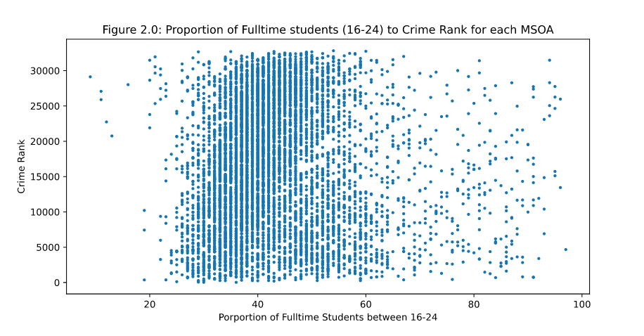
Figure 2.0: Proportion of full-time students (16-24) to crime rank for each MSOA

No clear trend was immediately visible, I therefore plotted a regression line to confirm visually (see Figure 2.1).

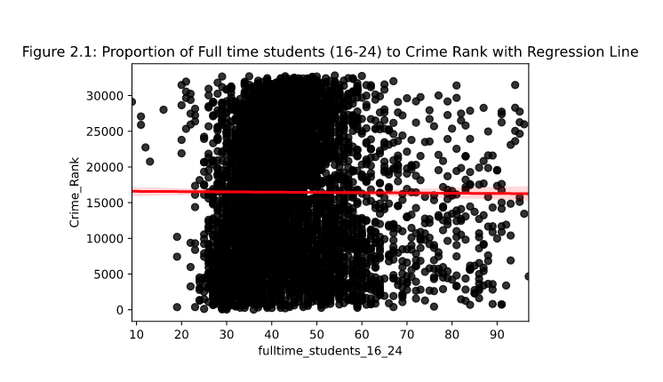
Figure 2.1: Proportion of full-time students (16-24) to crime rank with regression line

As shown by the regression line there appears to be no significant relation between the proportion of full-time students and crime rank.

In the case of the second question, another scatter plot was created.
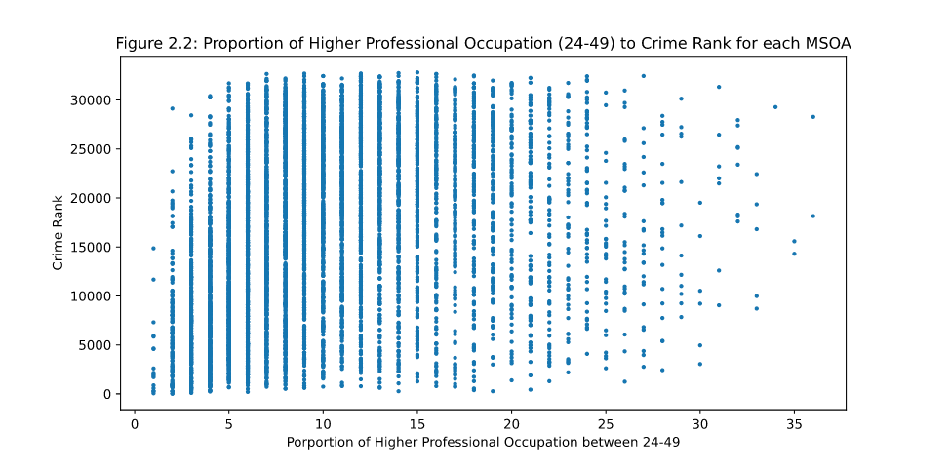
Figure 2.2: Proportion of higher profession occupations (25-49) to crime rank for each MSOA

Visually there appeared to possibly be a trend. A regression line was subsequently added (see Figure 2.3).
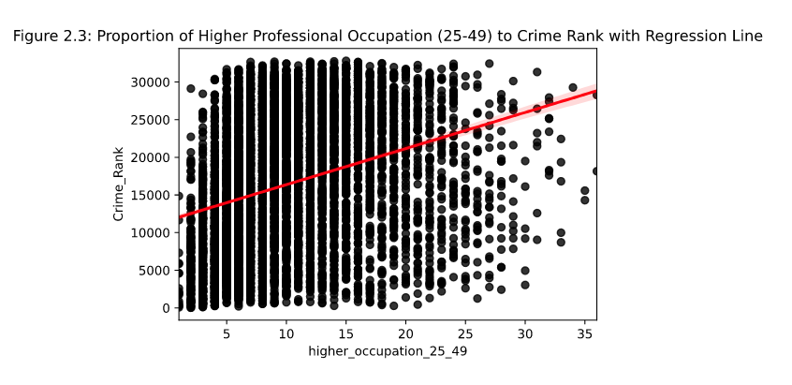
Figure 2.3: Proportion of higher profession occupations (25-49) to crime rank with regression line

The regression line (figure 2.3) shows a potential positive relationship between the proportion of higher professional occupations and crime rank.

With the establishment of a positive relationship between higher professional occupations and crime rank, I next examined whether there was a crime rank trend between high conversion areas (Q1) and low conversion areas (Q3).

In order to examine this, I calculated the mean and standard deviation of all the MSOAs in the Q1 and Q3 categories. The results are displayed below as a bar chart (see figure 3.0).

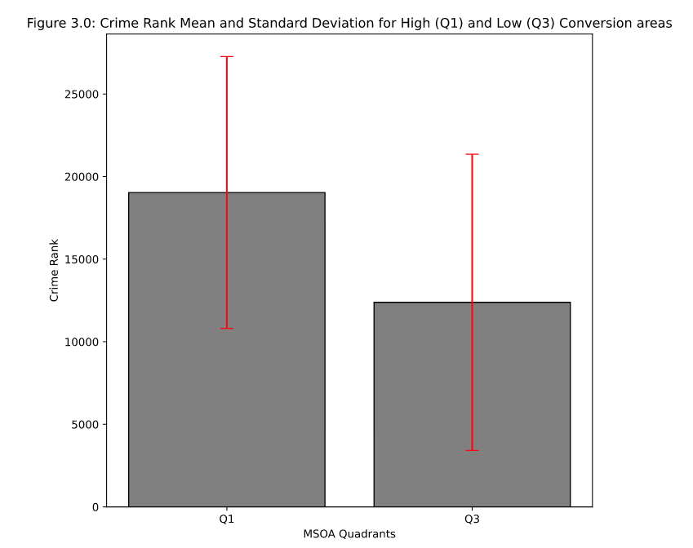
Figure 3.0: Crime Rank Mean and Standard Deviation for High (Q1) and Low (Q3) Conversion areas

The bar chart shows that areas in Q1 have a higher crime rank (therefore lower crime) than areas in Q3. The standard deviation is not significantly different in both instances which shows similar dispersion from the mean in both datasets.

Findings

Census data findings

The investigation of the Census dataset showed that there is a positive relationship between the proportions of full-time students (16-24 age range) and the proportions of higher professional occupation (25-49 age range) for each MSOA (see figure 1.2). That is to say, areas with a higher proportional full-time student population also have a higher proportion of higher professional occupations. The regression line suggests a strong relationship may be present. However, further research would be required in order to make a more definitive claim on this matter. The study also produced k-NN classifiers with the ability to predict which conversion quadrants an MSOA would fall under if given proportional student and higher occupation data.

Combined Deprivation and Census data findings

The combination of the Proportions and Deprivation datasets showed that between crime ranks and proportion of full-time students in an MSOA there seemed to be no significant relationship (see figure 2.1). However, there appeared to be a strong relationship between the proportion of individuals in higher professional occupations in an MSOA and crime ranking (see figure 2.3). Whether higher professional occupation proportions have a causal relationship with a higher crime ranking, or vice versa, cannot be inferred with the current findings alone and further research would be required to make a more definitive claim. While this study is able to highlight initial concepts and potential relationships, the multi-factorial aspect of the Deprivation Indices and Census data requires a more in-depth scope to fully elucidate clear trends.

Finally, the study found that areas with higher conversion (Q1) have a higher crime rank than areas with lower conversion (Q3) (see figure 3.0). No concrete conclusion can be made with this finding alone either. However, if further investigations demonstrate there to be a significance connection between crime and different conversion quadrants, we could suggest that being in a higher crime area limits the opportunities for full-time students to move into higher occupations roles despite being in a higher student population initially. This could imply that even though these areas have higher education levels, crime plays a factor in limiting student progression into better roles in the labour market.

Conclusions and recommendations

Census data can help reveal many interesting facts, not only about groups of people but also about the areas they reside in. Combined with Deprivation data it can help shed light on areas of educational and occupational vulnerabilities within society. This study aimed to use census data to highlight relationships between full-time students in the early stages of their lives and individuals in higher professional occupation in the prime of their working years. It aimed to show that there is a relationship between crime ranking, full-time students and professional occupations. This study however did not have scope to show the degree of statistical significance between these relationships. It is, therefore, this author’s recommendation that additional studies be carried out to further expand on our understanding of the links between crime, education and professional occupations within areas in England. This type of analysis could help to elucidate the factors that may be holding back the movement from full-time students into higher professional occupations, including crime as a factor.

Reflection

The Census files, the Deprivation files as well as my own Proportions files were saved as csv documents. The datasets were simple and small enough to not require complex storage methods. Should this study be continued and expanded on in the future a more robust database solution such as Postgres or MongoBD would be a suitable option. The Census datasets were all fairly clean and easy to work with. The combination of the 16-24 and 25-49 age range datasets also resulted in a small dataset which was easily usable, fit into memory and could be used for k-NN training and testing without any issues. I did struggle with the premise of the k-NN and felt that my classifiers might be quite arbitrary. Despite that I was pleased with how well they predicted the MSOA quadrants. The biggest challenge was in merging the Deprivation dataset containing LSOAs with the Census dataset containing MSOAs while using the lookup dataset. There were a lot of duplication and confusing terminology. However, with some guidance and research into how to do this I was able to successful merge these for use in this project and draw some conclusions as a result.

References

Office of National Statistics (2021) About the census [Online]. Available at https://census.gov.uk/about-the-census/why-you-should-take-part (Accessed 27 May 2021)

Department for Communities and Local Government (2015) The English indices
of deprivation 2015. Available at:
https://www.gov.uk/government/statistics/english-indices-of-deprivation-2015
(Accessed: 27 May 2021).

nomis – office labour market statistics (n.d.a) DC6206EW - NS-SeC by ethnic group by sex by age [Online]. Available at https://www.nomisweb.co.uk/query/construct/summary.asp?mode=construct&version=0&dataset=682 (Accessed 27 May 2021)

Office of National Statistics (2011) Statistical disclosure control methods [Online]. Available at https://webarchive.nationalarchives.gov.uk/20160129174312/http://www.ons.gov.uk/ons/guide-method/census/2011/census-data/2011-census-user-guide/quality-and-methods/methods/statistical-disclosure-control-methods/index.html (Accessed 27 May 2021)

Appendices

